1. Abstract

Internet has changed the world in its wake and nothing we see or do is left from its influence. From shopping to selling everything is done on the internet and as the landscape changes so does the methods to market your product there are fledgling startups with limited media platforms and budgets to pour into the social networks. They generally consist of a group of passionate hustlers hungry to make an impact. Generally, they have a few thousand dollars in the content marketing budget, if that. But, they are ruthless and like to take *action* to take social media marketing by storm. This is where just a marketer is not enough we need someone with greater understanding of growth and someone who can focus on just a couple of important things and ignoring all others. *Social media doesn’t care about a business’ marketing budget.* This absolute focus on growth has given rise to a number of methods, tools, and best practices that simply didn’t exist in the traditional marketing repertoire and as time passes the chasm between the two discipline deepens. consists of users that regularly await interesting and amusing stories to show up on their social media feeds. As soon as a user sees a post on their media account with a story that’s relevant and that awes him – he puts the effort to share the story across his social network.So, even small businesses manage to go viral on social media and put their brand in front of hundreds of thousands of people and take social media marketing by storm.

2. Introduction

Social media marketing refers to the process of gaining traffic or attention through social media sites. Its an umbrella term which includes all the platforms which can be called as social network sites (SNS). That’s why social media is a fertile marketing channel for an average Joe, like you and me. In the past, businesses have built an audience on social media by sharing entertaining, high-quality and useful content. Their audience goes on to share that content across their social media accounts and the rest is history.

Social media marketing is the use of social media platforms and websites to promote a product or service. Although the terms e-marketing and digital marketing are still dominant in academia, social media marketing is becoming more popular for both practitioners and researchers. Most social media platforms have built-in data analytics tools, which enable companies to track the progress, success, and engagement of ad campaigns. Companies address a range of stakeholders through social media marketing, including current and potential customers, current and potential employees, journalists, bloggers, and the general public. On a strategic level, social media marketing includes the management of a marketing campaign, governance, setting the scope (e.g. more active or passive use) and the establishment of a firm's desired social media "culture" and "tone."

When using social media marketing, firms can allow customers and Internet users to post user-generated content (e.g., online comments, product reviews, etc.), also known as "earned media," rather than use marketer-prepared advertising copy.Social networking websites are based on building virtual communities that allow consumers to express their needs, wants and values, online. Social media marketing then connects these consumers and audiences to businesses that share the same needs, wants, and values.

Through social networking sites, companies can keep in touch with individual followers. This personal interaction can instill a feeling of loyalty into followers and potential customers. Also, by choosing whom to follow on these sites, products can reach a very narrow target audience. Social networking sites also include much information about what products and services prospective clients might be interested in. Through the use of new semantic analysis technologies, marketers can detect buying signals, such as content shared by people and questions posted online. An understanding of buying signals can help sales people target relevant prospects and marketers run micro-targeted campaigns.

“

3. What is Growth Hacking?

Growth hacking is a process of rapid experimentation across marketing funnel, product development, sales segments, and other areas of the business to identify the most efficient ways to grow a business. A growth hacking team is made up of marketers, developers, engineers and product managers that specifically focus on building and engaging the user base of a business.

A growth hacker is not a replacement for a marketer. A growth hacker is not better than marketer. A growth hacker is just different than a marketer. To say it in Sean’s words, *“A growth hacker is a person whose true north is growth."*

Every decision that a growth hacker makes is informed by growth. Every strategy, every tactic, and every initiative, is attempted in the hopes of growing. Growth is the sun that a growth hacker revolves around. Of course, traditional marketers care about growth too, but not to the same extent. Remember, the power of a growth hacker is in their obsessive focus on a singular goal. By ignoring almost everything, they can achieve the one task that matters most early on.

3.1 Redefining Product

There has been a monumental change in what can be termed as a product with the commencement of internet age. Not just shampoo, couches and television but also things which you cannot hold such as platforms like twitter and facebook are termed as products. Sean who coined the term ‘Growth Hacker’ says, “Growth hackers understand the latent potential of software products to spread themselves, and it’s their responsibility to transform this potentiality into a reality.”

3.2 Redefining Distribution

Internet provides the online infrastructure necessary to redirect and concentrate traffic. Internet is more important now than ever before, it drives everything that we do and controls our action. From personalized marketing and feeds to social media, internet shapes our mind and how we use it.

Social media offer different values to firms, such as enhanced brand popularity, facilitating work-of-mouth communication, increasing sales, sharing information in a business context and generating social support for consumers.

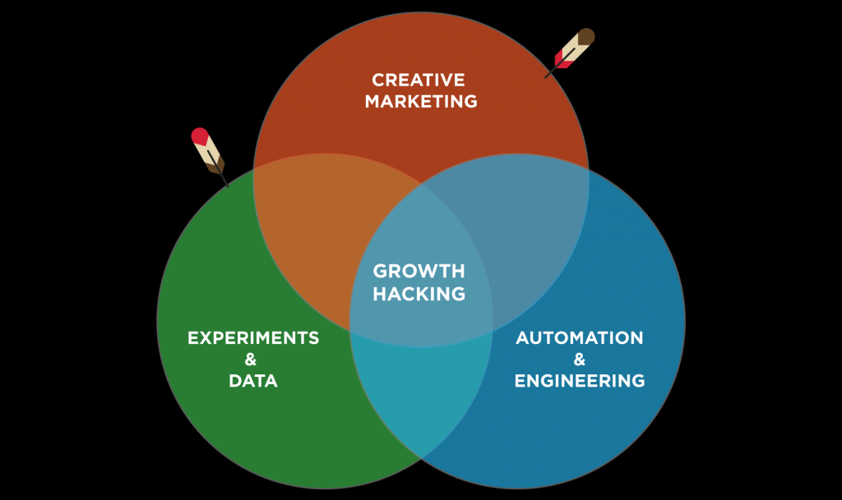

Figure 1. (Source: [https://www.quicksprout.com](https://www.quicksprout.com/))

## 4. Platforms

### 4.1 Social networking websites

Social networking websites allow individuals, businesses and other organizations to interact with one another and build relationships and communities online. When companies join these social channels, consumers can interact with them directly.That interaction can be more personal to users than traditional methods of outbound marketing and advertising. Social networking sites act as word of mouth or more precisely, e-word of mouth. The Internet's ability to reach billions across the globe has given online word of mouth a powerful voice and far reach. The ability to rapidly change buying patterns and product or service acquisition and activity to a growing number of consumers is defined as an influence network. Social networking sites and blogs allow followers to "retweet" or "repost" comments made by others about a product being promoted, which occurs quite frequently on some social media sites.By repeating the message, the user's connections are able to see the message, therefore reaching more people. Because the information about the product is being put out there and is getting repeated, more traffic is brought to the product/company.

Social networking websites are based on building virtual communities that allow consumers to express their needs, wants and values, online. Social media marketing then connects these consumers and audiences to businesses that share the same needs, wants, and values. Through social networking sites, companies can keep in touch with individual followers. This personal interaction can instill a feeling of loyalty into followers and potential customers. Also, by choosing whom to follow on these sites, products can reach a very narrow target audience. Social networking sites also include much information about what products and services prospective clients might be interested in. Through the use of new semantic analysis technologies, marketers can detect buying signals, such as content shared by people and questions posted online. An understanding of buying signals can help sales people target relevant prospects and marketers run micro-targeted campaigns.

In 2014, over 80% of business executives identified social media as an integral part of their business.Business retailers have seen 133% increases in their revenues from social media marketing.

### 4.2 Mobile phones

More than three billion people in the world are active on the Internet. Over the years, the Internet has continually gained more and more users, jumping from 738 million in 2000 all the way to 3.2 billion in 2015.Roughly 81% of the current population in the United States has some type of social media profile that they engage with frequently.  Mobile phone usage is beneficial for social media marketing because mobile phones have social networking capabilities, allowing individuals immediate web browsing and access to social networking sites. Mobile phones have grown at a rapid rate, fundamentally altering the path-to-purchase process by allowing consumers to easily obtain pricing and product information in real time. and allowing companies to constantly remind and update their followers. Many companies are now putting QR (Quick Response) codes along with products for individuals to access the company website or online services with their smart phones. Retailers use QR codes to facilitate consumer interaction with brands by linking the code to brand websites, promotions, product information, or any other mobile-enabled content. In addition, Real-time bidding use in the mobile advertising industry is high and rising because of its value for on-the-go web browsing. In 2012, Nexage, a provider of real time bidding in mobile advertising, reported a 37% increase in revenue each month. Adfonic, another mobile advertisement publishing platform, reported an increase of 22 billion ad requests that same year.Mobile devices have become increasingly popular, where 5.7 billion people are using them worldwideand this has played a role in the way consumers interact with media and has many further implications for TV ratings, advertising, mobile commerce and more. Mobile media consumption such as mobile audio streaming or mobile video are on the rise – in the United States, more than 100 million users are projected to access online video content via mobile device. Mobile video revenue consists of pay-per-view downloads, advertising, and subscriptions. As of 2013, worldwide mobile phone Internet user penetration was 73.4%. In 2017, figures suggest that more than 90% of Internet users will access online content through their phones.

## 5. Strategies

There are two basic strategies for engaging the social media as marketing tools:

### 5.1 Passive approach

Social media can be a useful source of market information and a way to hear customer perspectives. Blogs, content communities, and forums are platforms where individuals share their reviews and recommendations of brands, products, and services. Businesses are able to tap and analyze the customer voices and feedback generated in social media for marketing purposes;] in this sense the social media is a relatively inexpensive source of market intelligence which can be used by marketers and managers to track and respond to consumer-identified problems and detect market opportunities. For example, the Internet erupted with videos and pictures of iPhone 6 "bend test" which showed that the coveted phone could be bent by hand pressure. The so-called "bend gate" controversy created confusion amongst customers who had waited months for the launch of the latest rendition of the iPhone. However, Apple promptly issued a statement saying that the problem was extremely rare and that the company had taken several steps to make the mobile device's case stronger and robust. Unlike traditional market research methods such as surveys, focus groups, and data mining which are time-consuming and costly, and which take weeks or even months to analyze, marketers can use social media to obtain 'live' or "real time" information about consumer behavior and viewpoints on a company's brand or products. This can be useful in the highly dynamic, competitive, fast-paced and global marketplace of the 2010s.

### 5.2 Active approach

Social media can be used not only as public relations and direct marketing tools but also as communication channels targeting very specific audiences with social media influencers and social media personalities and as effective customer engagement tools.Technologies predating social media, such as broadcast TV and newspapers can also provide advertisers with a fairly targeted audience, given that an ad placed during a sports game broadcast or in the sports section of a newspaper is likely to be read by sports fans. However, social media websites can target niche markets even more precisely. Using digital tools such as Google Adsense, advertisers can target their ads to very specific demographics, such as people who are interested in social entrepreneurship, political activism associated with a particular political party, or video gaming. Google Adsense does this by looking for keywords in social media user's online posts and comments. It would be hard for a TV station or paper-based newspaper to provide ads that are this targeted (though not impossible, as can be seen with "special issue" sections on niche issues, which newspapers can use to sell targeted ads).

Social networks are, in many cases, viewed as a great tool for avoiding costly market research. They are known for providing a short, fast, and direct way to reach an audience through a person who is widely known. For example, an athlete who gets endorsed by a sporting goods company also brings their support base of millions of people who are interested in what they do or how they play and now they want to be a part of this athlete through their endorsements with that particular company. At one point consumers would visit stores to view their products with famous athletes, but now you can view a famous athlete's, such as Cristiano Ronaldo, latest apparel online with the click of a button. He advertises them to you directly through his Twitter, Instagram, and FaceBook accounts.

Facebook and LinkedIn are leading social media platforms where users can hyper-target their ads. Hypertargeting not only uses public profile information but also information users submit but hide from others. There are several examples of firms initiating some form of online dialog with the public to foster relations with customers. According to Constantinides, Lorenzo and Gómez Borja (2008) "Business executives like Jonathan Swartz, President and CEO of Sun Microsystems, Steve Jobs CEO of Apple Computers, and McDonalds Vice President Bob Langert post regularly in their CEO blogs, encouraging customers to interact and freely express their feelings, ideas, suggestions, or remarks about their postings, the company or its products". Using customer influencers (for example popular bloggers) can be a very efficient and cost-effective method to launch new products or services[]](https://en.wikipedia.org/wiki/Social_media_marketing" \l "cite_note-18) Among the political leaders in office, Prime Minister Narendra Modi has the highest number of followers at 40 million, and President Donald Trump ranks second with 25 million followers.Modi employed social media platforms to circumvent traditional media channels to reach out to the young and urban population of India which is estimated to be 200 million.

## 5.3 Engagement

In the context of the social web, engagement means that customers and stakeholders, such as consumer advocacy groups and groups that criticize companies (e.g., lobby groups or advocacy organizations) are active participants rather than passive viewers. Social media use in a business or political context allows all consumers/citizens to express and share an opinion about a company's products, services or business practices, or a government's actions. Each participating customer or non-customer (or citizen) who is participating online via social media becomes part of the marketing department (or a challenge to the marketing effort), as other customers read their positive or negative comments or reviews. Getting consumers and potential consumers (or citizens) to be engaged online is fundamental to successful social media marketing. With the advent of social media marketing, it has become increasingly important to gain customer interest in products and services, which can eventually be translated into buying behavior (or voting or donating behavior in a political context). New online marketing concepts of engagement and loyalty have emerged which aim to build customer participation and brand reputation.

Engagement in social media for the purpose of a social media strategy is divided into two parts. The first is proactive, regular posting of new online content (digital photos, digital videos, text) and conversations, as well as the sharing of content and information from others via weblinks. The second part is reactive conversations with social media users responding to those who reach out to your social media profiles through commenting or messaging Traditional media such as TV news shows are limited to one-way interaction with customers or 'push and tell' where only specific information is given to the customer with few or limited mechanisms to obtain customer feedback. Traditional media such as paper newspapers, of course, do give readers the option of sending a letter to the editor, but this is a relatively slow process, as the editorial board has to review the letter and decide if it is appropriate for publication. On the other hand, social media is participative and open, as participants are able to instantly share their views on brands, products, and services. Traditional media gave control of message to the marketer, whereas social media shifts the balance to the consumer (or citizen).

6. Great examples by other startups

There have been numerous cases where we can see an explosion in the number of users for a particular product. Instagram, facebook, Airbnb are just to name a few. They have successfully implemented the growth strategies and above all have a great product to work with. After carefully analyzing the market and studying the users they decided to target the user base which is most relevant to their own interest.

Which gave them the needed edge over others. Once it starts growing then it all depends on your product and its quality therefore it is necessary to keep in mind the user’s feedback and changing and adapting the product accordingly. The Internet's ability to reach billions across the globe has given online word of mouth a powerful voice and far reach. The ability to rapidly change buying patterns and product or service acquisition and activity to a growing number of consumers is defined as an influence network.[[5]](https://en.wikipedia.org/wiki/Social_media_marketing" \l "cite_note-Change-5) Social networking sites and [blogs](https://en.wikipedia.org/wiki/Blogs) allow followers to "retweet" or "repost" comments made by others about a product being promoted, which occurs quite frequently on some social media sites.[[6]](https://en.wikipedia.org/wiki/Social_media_marketing" \l "cite_note-faculty.ist.psu.edu-6) By repeating the message, the user's connections are able to see the message, therefore reaching more people. Because the information about the product is being put out there and is getting repeated, more traffic is brought to the product/company

6.1 Airbnb

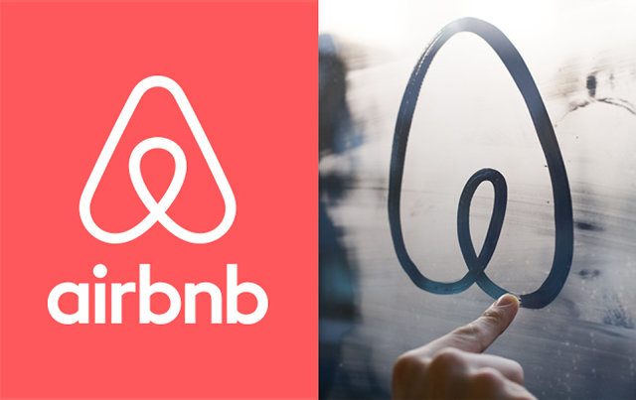

Figure 2. (Source: [https://www.quicksprout.com](https://www.quicksprout.com/))

In 2007, designers Brian Chesky and Joe Gebbia couldn’t afford the rent on their San Francisco apartment. To make ends meet, they decided to turn their loft into a lodging space, but, as Gebbia explains, “We didn’t want to post on Craigslist because we felt it was too impersonal. Our entrepreneur instinct said ‘build your own site.’ So we did.”

There was a design conference coming to town and hotel space was limited, so they set up a simple website with pictures of their their loft-turned-lodging space—complete with three air mattresses on the floor and the promise of a home-cooked breakfast in the morning. This site got them their first three renters, each one paying $80, and after that first weekend they began receiving emails from people around the world asking when the site would be available for destinations like Buenos Aires, London, and Japan. Gebbia explains:

The following spring, they enlisted former roommate and engineer Nathan Blecharczyk to help them get Airbed & Breakfast off the ground. They planned the launch around the Democratic National Convention in order to capitalize on the resulting lack of hotel space. Fast forward seven years, and Airbed and Breakfast is now Airbnb—a household name that has surpassed industry legacy Hilton Hotels in nights booked. As of spring 2014, the platform had 10 million guests and 550,000 properties listed worldwide, along with a $10B valuation—making Airbnb worth more than legacy players like Wyndham and Hyatt.The company has received $776.4M from investors like Y Combinator, Sequoia Capital, Keith Rabois, Andreessen Horowitz, Ashton Kutcher, Founders Fund, and TPG Growth in a total of seven funding rounds—the last of which raised $500M alone.

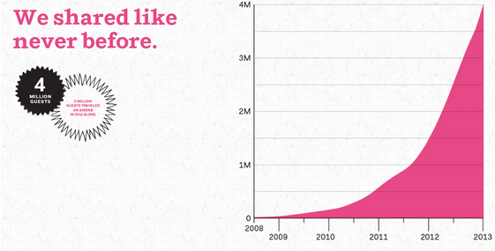

Figure 3. (Source: [https://www.quicksprout.com](https://www.quicksprout.com/))

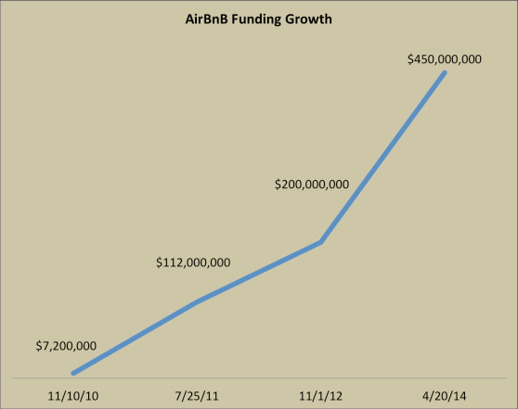

Figure 4. (Source: [https://www.quicksprout.com](https://www.quicksprout.com/))

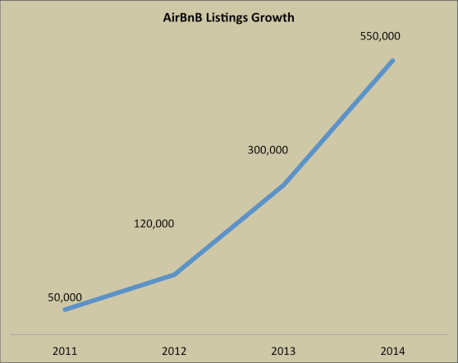

Figure 5. (Source: [https://www.quicksprout.com](https://www.quicksprout.com/))

6.2 Instagram

Instagram is the largest-growing social-media platform. It was a success right from the beginning with over a million users only two months after it was launched. Instagram was developed in San Francisco by Kevin Systrom and Mike Krieger. Systrom was working in marketing and started doing engineering at night to help him learn how to code. He created a prototype app of an idea he originally called Burbn, which allowed people to check-in where they are on their mobile web app. After meeting people who worked for venture capitalist firms at a party, Systrom got them to agree to a meeting to discuss Burbn. After the first meeting, he quit his job and two weeks later he had raised $500,000 from the firms.

At this point, Systrom decided to find a team to help him and Mike Krieger agreed to join. They decided that the app was very similar to other already established mobile apps, so they pivoted to focus solely on communication through images. They stripped out all the features from the app except uploading photos, commenting and liking. It was renamed Instagram which referred to the fact that users were sending a type of instant telegram.

Instagram launched on 6th October 2010 and its growth was nearly instantaneous. From a handful of users, it soon became the number one photography app gathering 100,000 users in one week, increasing to 1 million in two months. According to Kevin Systrom, the app itself took only eight weeks to build but was a result of over a year of work behind it. It went on to be bought by Facebook for $1 billion in 2012. It now has over 600 million active users and is still increasing quickly.

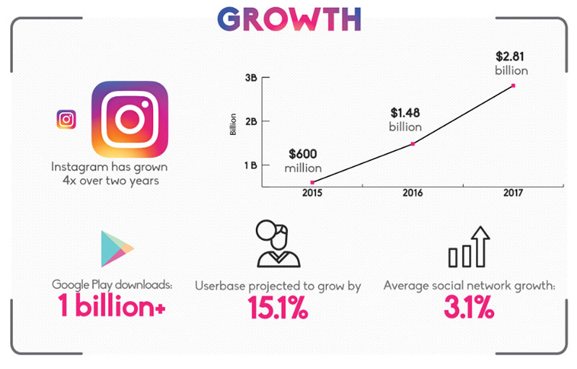

Figure 6. (Source: [https://www.nielpatel.com](https://www.nielpatel.com/))

6.3 Dropbox

As any other online marketer would do, Dropbox was initially invested in digital ads. *“They were incurring a cost of acquisition of over $250 for a product which was priced at $99”*

However, they quickly figured out that it was not going to work out. They shifted their model to referral marketing that took them from **100,000 to 4,000,000 users in 15 months.** Dropbox launched a simple referral program where you could invite your friends and win free cloud storage space. The program looked like this

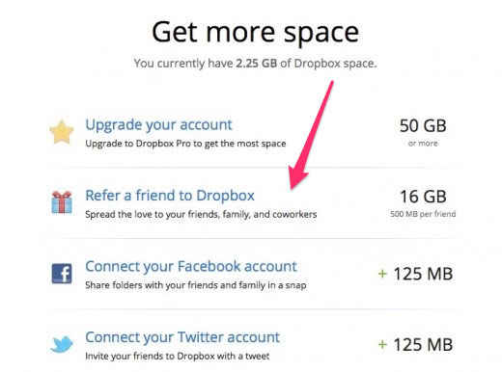

Figure 7. (Source: [https://www.nielpatel.com](https://www.nielpatel.com/))

Other than that, they also made the process of inviting a friend super-easy.Word of mouth marketing works better than anything else. If you already have customers who love your product/service, you should consider encouraging them for inviting their friends/network to use your product/service.

7. Implementation of Growth Hacking methods

The product markets itself on the basis of how it works.

7.1 Make sure you make a product people actually want

Gone is the time when you could get away with a mediocre product if you market it enough.  For example coke introduced other soft drinks such as sprite and fanta. And they don’t taste as good as coke. But through extensive marketing they got away with it and today we can see these drinks beside coke in the aisle.

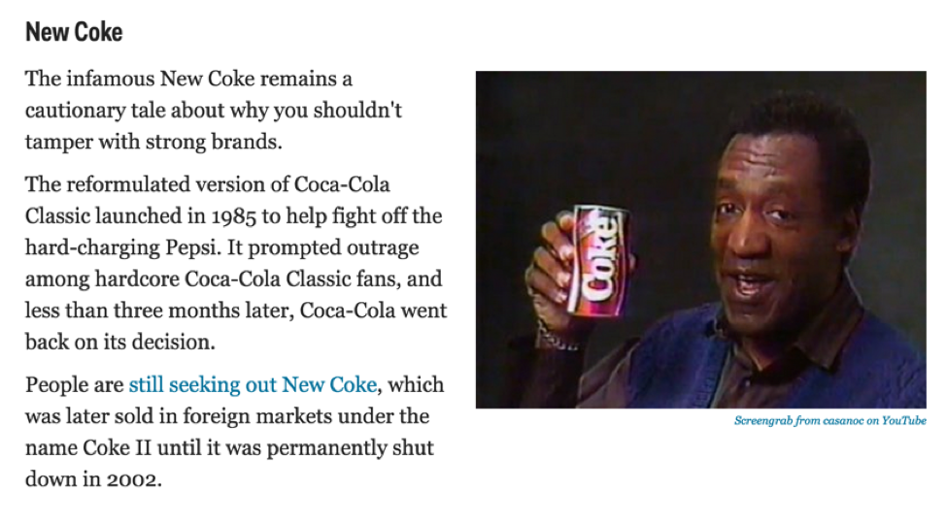

Figure 8. (Source: [https://www.nielpatel.com](https://www.nielpatel.com/))

One way to make sure that your product reaches the right audiences and is perceived in the correct way is to take feedback. Today it’s easier than ever to take a feedback from all the social network sites and blogs.

And not just taking feedbacks but at the same time acting on them and making relevant changes which will push the product towards being what the customer wants.

7.2 Don’t Target Everybody

Choose your audience carefully and cater to their needs and feedbacks. Spreading your area too much will just make the product into a mixed breed which will not be able to satisfy anyone.

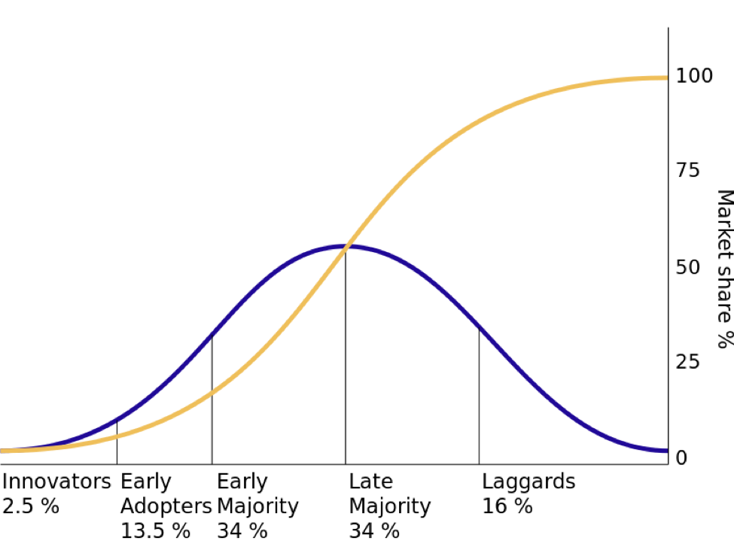

Figure 9. (Source: [https://www.nielpatel.com](https://www.nielpatel.com/))

There is a threshold which every new product should cross in order to reach the point of maximum utilization, its called the law of diffusion of innovation. We can get many examples from the more established startups which have used targeted marketing as a way to overcome the threshold and reach the tipping point.For example dropbox initially used the refer to sign-up process where only current users can refer new users. This created an air of exclusivity around the product and hence achieved the target.

The startup metrics have been given to measure the true growth potential and ignore everything else.He outlined the metrics by funnel stages in the helpful acronym AARRR. Users then affectionately nicknamed it “Pirate Metrics.”

The funnel stages outlined included:

1. Acquisition: How you get people to know you by name.
2. Activation: How to give users a happy first experience.
3. Retention: How you keep them coming back for more.
4. Revenue: How you monetize them.
5. Referral: How you get them to tell other people.

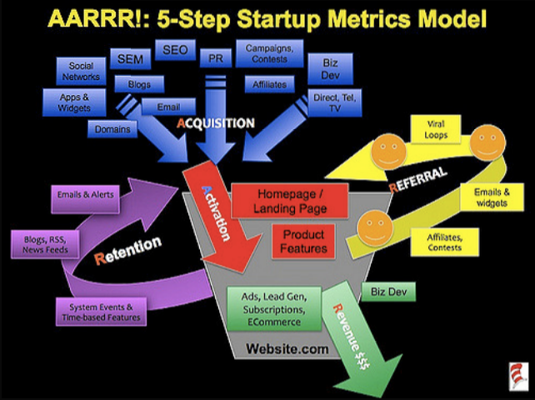

Figure 10. (Source: [https://www.nielpatel.com](https://www.nielpatel.com/))

It’s not just about acquisition which is easy through ads but retention is the key to more customer retention. As we can see in this image given below which shows the average retention rate of an android app.

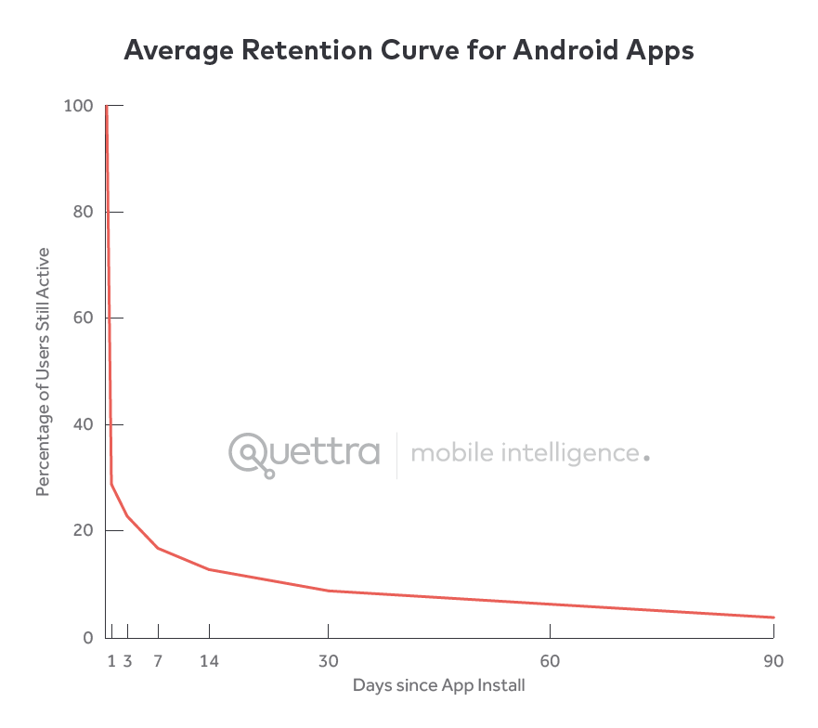

Figure 10. (Source: [https://www.quicksprout.com](https://www.quicksprout.com/))

7.4 Pick a growth model that works best for your product

* Go viral through incentivizing the sharing of your product (it should become better with more users)

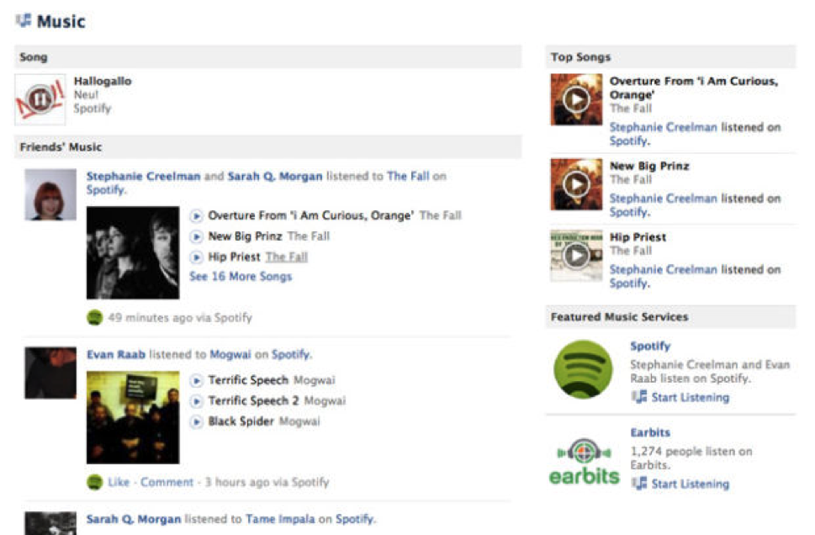

Figure 11. (Source: [https://www.nielpatel.com](https://www.nielpatel.com/))

* Retain users over the long haul with sticky features
* Or increase the lifetime value of each customer so you can profitably buy new customers

7.5 Activate customers by giving them a “happy first experience”

* Streamline user flows to get people into the product quickly

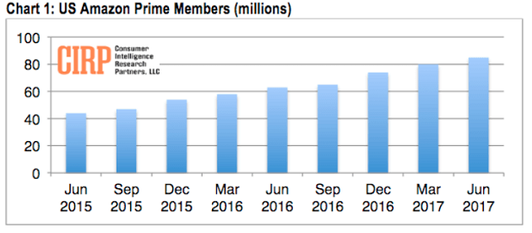Figure 12 (Source: [https://www.nielpatel.com](https://www.nielpatel.com/))

* Create product tutorials to seamlessly onboard customers

7.6 Retain users by combining messaging across channels

* Add paid remarketing campaigns to your triggered emails

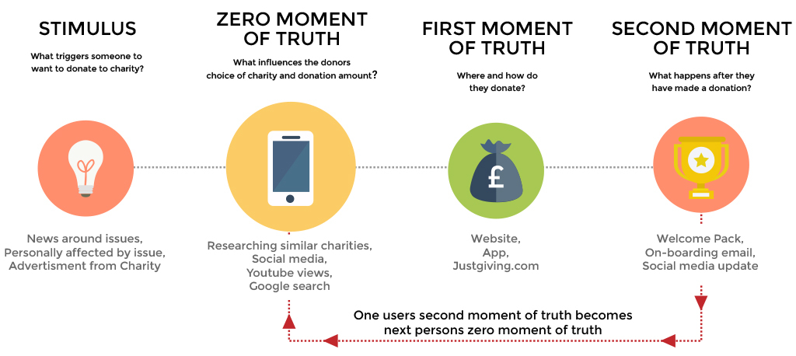

Figure 12. (Source: [https://www.nielpatel.com](https://www.nielpatel.com/))

* Plan them in advance to switch messaging based on whether people do or don’t stick around

7.7 Never stop trying to front-load cash

* Big revenue increases can be as simple as getting customers to prepay

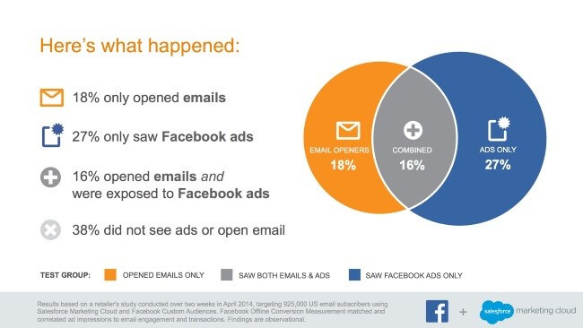

Figure 13. (Source: [https://www.quicksprout.com](https://www.quicksprout.com/))

* This smoothes out cash flow problems notorious with product companies
* Focus on low hanging fruit like abandon cart emails for e-commerce to save people who might leave without buying

7.8 Use simple metrics to predict your product’s referral potential

* Net Promoter Score predicts if people will recommend you to their friends or colleagues
* Compare that number over time or against industry benchmarks
* Viral products need a viral coefficient greater than one to grow

7.9 Keep improving your product by:

* Constantly iterating and releasing updates
* Testing every detail
* Optimizing the onboarding process

8. Conclusion and further development

The ultimate goal of this is to define and explore Growth Hacking, a relatively new term coined in 2010 as previously we have provided the knowledgebase for understanding of the concept of growth hacking.Growth hacking offers a fresh new take on the traditional ideology of marketing and more so, a cost effective way of realizing a fresh marketing strategy specifically applicable to a company in its initial phase. Based on the theory of growth hacking and the empirical evidence of its application and counterparts, it is a pragmatic statement to say that it would be very viable and convenient growth strategy for the company to use in both domestic and international stages of expansion. As evidenced by the successes of some of the highest profile growth hacked businesses such as IT giants of social media and instagram the ideology and methodology of growth hacking’s “change to adapt” practice should serve as an important lesson for the companies in their beginning stages which are looking forward to growing and expanding the business. Likewise, it is strongly suggested for the case company to do their own research into businesses that they might have some more similarities with and try to find inspiration in their success or failure in growth hacking. Each compay should start by creating a domestic iage and testing their marketing strategy deelopment in a familiar environment before looking to foreign markets. Additionally, it would be recommended to hire a marketing advisor either as an outsourced professional or as in-house employee. In order to have a solid platform for growth hacking, several conditions should be met, such as:

* Having a sebsite and social media marketing presence online
* Integrating the marketing communication through one channel
* Creating a ubiquitous corporate message across all media
* Streamlining the marketing communication.

A marketing strategy set up in this way should allow for an effective growth hacking foundation to be possible. Furthermore, the whole marketing effort should be structured in a way that is easily scalable and more importantly, fully trackable and measurable.